DSA06 – Data Handling and Visualization
Activity: Identify Skewness using Violin Plots | Slot D
R.No: 40 Reg. No: 192525102 Name: Yashika R
Part A (18 marks). Each chart is a violin plot (white dot = median) made in R with ggplot2. For every violin circle the skew (1 mark) and the relation of the mean to the median (0.5 mark).
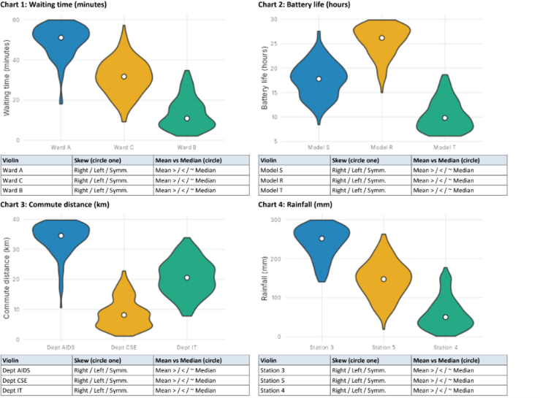

Part A – Identify the Skewness (18 marks)
Note: The white circle represents the median. The mean–median relationship is identified from the direction of the skew: right-skewed → mean > median; left-skewed → mean < median; symmetric → mean ≈ median.

Chart 1: Waiting time (minutes)
Violin / Group | Skew | Mean vs Median
Ward A | Left-skewed | Mean < Median
Ward C | Approximately symmetric | Mean ≈ Median
Ward B | Right-skewed | Mean > Median

Chart 2: Battery life (hours)
Violin / Group | Skew | Mean vs Median
Model S | Approximately symmetric | Mean ≈ Median
Model R | Left-skewed | Mean < Median
Model T | Right-skewed | Mean > Median

Chart 3: Commute distance (km)
Violin / Group | Skew | Mean vs Median
Dept AIDS | Left-skewed | Mean < Median
Dept CSE | Right-skewed | Mean > Median
Dept IT | Approximately symmetric | Mean ≈ Median

Chart 4: Rainfall (mm)
Violin / Group | Skew | Mean vs Median
Station 3 | Left-skewed | Mean < Median
Station 5 | Approximately symmetric | Mean ≈ Median
Station 4 | Right-skewed | Mean > Median

Part B – Questions and Answers (2 marks)

B1. In Chart 1, violin “Ward A” is not symmetric. Towards which side is its tail, and which is the better measure of a typical waiting time here: mean or median? Give one reason. (1 mark)
Answer: Ward A has a tail towards the lower waiting-time values (left-skewed). The median is the better measure of a typical waiting time because it is less affected by skewness and extreme values.

B2. Write one ggplot2 line that draws violins of value for each group from a data frame df (columns group, value), with the median shown. (1 mark)
Answer:
ggplot(df, aes(x = group, y = value)) + geom_violin() + stat_summary(fun = median, geom = "point", shape = 21, fill = "white")

